|  |  |
| --- | --- |
|  |  |

**APPLICATION FOR THE LINDAU PROGRAM**

|  |  |  |  |
| --- | --- | --- | --- |
| **Topic** | **Interdisciplinary**  **（Chemistry, Physics and Medicine/Physiology）** | | |
| **Time of the Meeting** | **2026.6.28-07.03** | | |
| **Time of the Science Tour** | **The specific time will be advised in due course** | | |
| **Place** | **Lindau and other German cities during the Science Tour** | | |
|  | | | |
| **Name** |  | **Gender** |  |
| **Date of Birth** |  | **Place of Birth** |  |
| **Institute/University** |  | | |
| **Address/Zip Code**  **Phone**  **E-Mail** |  | | |
| **Field of Research** |  | | |
| **Certificates of English and other languages** |  | | |
| **Expected Date of Graduation** |  | | |

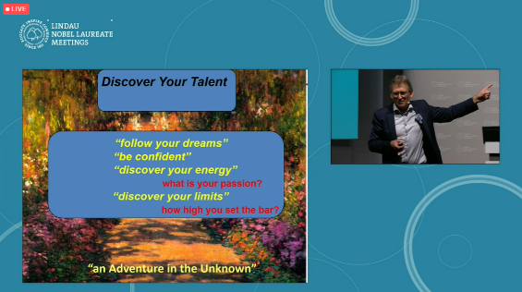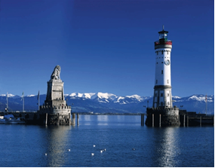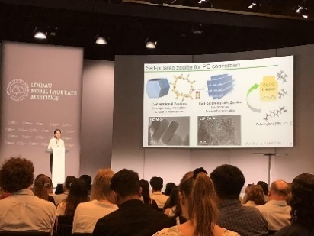

|  |
| --- |
| **1. Statement of your qualifications and reasons for wishing to attend the Nobel Laureate Meeting, especially:**  **a. Your research field: Please give a brief description of your thesis subject and outline of your research plan, describing the results you have already obtained and ongoing work. Please highlight the interdisciplinary nature of your work at the intersection of at least two Nobel disciplines (Physics, Chemistry, and Physiology/Medicine) OR at the intersection of a Nobel discipline and another discipline from the social or natural Sciences.**  **b. What influenced your decision to pursue a PhD and to choose your particular topic?**  **c. International experience: Have you had opportunities to discuss your research internationally, e.g. with visiting researchers from abroad, at international conferences or on visits to foreign research labs?**  **d. What is your career plan for the future?**  **(use Arial 12 point characters, single-spaced)** |

**Declaration**

**We confirm with our signature that the information provided by the applicant is true. We are willing to recommend the applicant to participate in the selection of the 75th**

**Lindau Nobel Laureate Meeting organized by the Sino-German Center.**

**_____________________ _______________________**

**Signature of the applicant Seal of the university**

**Attachment**

1. **Letter of recommendation from your thesis advisor and/or the academic committee of your current institution. Please fill in the template.**
2. **Curriculum vitae and publication list (5 most relevant publications for all participants) (If you are not the only author, please list your co-authors).**

**(one page at most, use Arial 12 point characters, single-spaced)**

1. **Copy of ID card**
2. **Published articles, Certificates of Scholarships and Certificates of English and other languages**